**Development House Type Landing page: The Spruce**

* **/new-homes/find-a-new-home/development/house-type**

**Page name:** House Type Name (For example ‘The Lauriston’): The Spruce

**Meta Title *(Digital to populate):***

**Meta Descriptions *(Digital to populate):***

***Breadcrumbs:*** *These will be automatically populated based on the page name*

**House Type Tag (highlight for list below or add your own below and highlight):**

* Last home remaining
* Selling fast
* Coming soon
* New to market
* Just launched
* Home of the month
* Home of the week
* Shared Ownership available
* Shared Equity available
* Flooring included throughout
* Exclusive offer available

**Promotional Flash:** 15 – 20 words max and can be hyperlinked to a plot page to push home of the month for example.



**H1:** Spruce

**Promotional line (under H1):** 84 characters long:  Shared Ownership at Newcourt Edge, Exeter

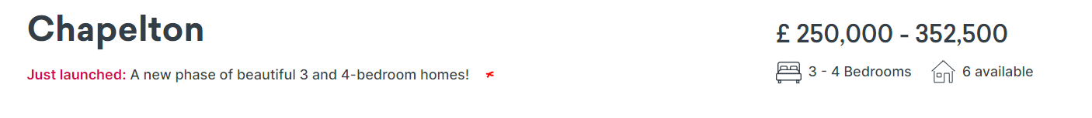

**Images:**

* Please supply a selection of **5-6 images** for the house type including a selection of external, internal images
* Min upload: 2560 x 1440px
* Recommended upload: 3840 x 2048 pixels
* Photography should be 16:9 aspect ratio and have good amount of real estate around the focus of the image, so enough vertical and horizontal spare space that when cropping the image (which we do in code) doesn't cut off too much of the picture, e.g., don't have a photo where the focus is touching the top or sides of the image because when its cropped some of the picture will be lost.
* 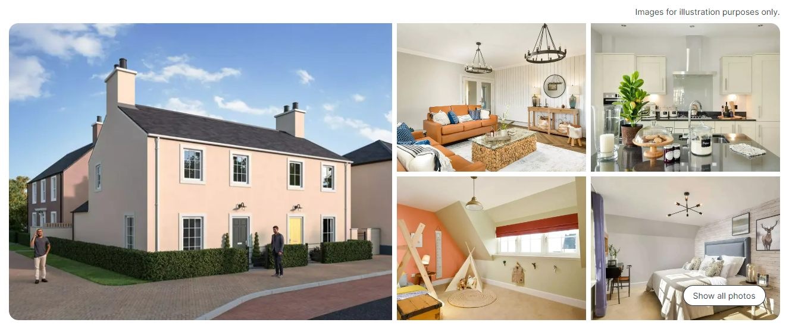**Disclaimer (auto populated):** Images are for illustration purposes only

**Key features:**

* Min/ Max 6 x key features to display per plot
* If you require a new one – please supply svg icon (from design) and ensure copy is max 20 characters long for each feature.
* Please refer to the agreed list and provide 6 x key features for each Development.
* List here (refer to plot level) [Key Feature Icons - Condensed.docx](https://placesforpeople365.sharepoint.com/sites/BrandDigital/_layouts/15/guestaccess.aspx?share=EbY6pDXxlYZFo5eZE8iZI3oBSEbt11JYeThHToi9xCn9rA&e=dH44JI)

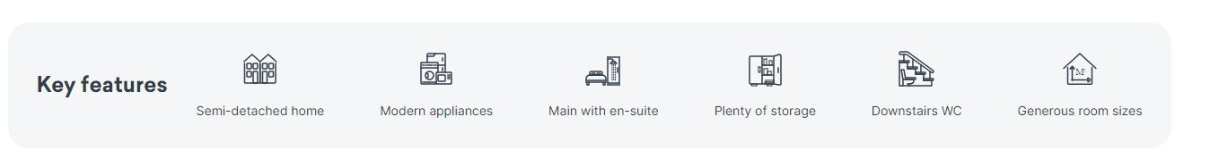

* Generous room sizes
* Off-road parking
* Modern appliances
* Plenty of storage
* First-time buyers
* Close to city centre

**Tabs (4 x tabs):**

**Overview**

* The most important information that will appeal to the home buyer should appear here about the house type (plural would work best as we’re talking about a house type not a specific plot)
* The ‘Read more’ allows for more storytelling if the user clicks this and max character count is used
* **Copy (760 characters max):** The Hazel is a stunning three bedroom home with ample space for you and your family. Featuring a kitchen/diner with French door access to the garden and three double bedrooms with Bedroom 1 benefiting from an en suite this home won’t be around for long so enquire today!

**Specification**

* Specification of plot to be included here and copy should be unique to the house type page.
* Please supply single page specification PDF (For more information, please **see the full list of specifications.)**
* **Copy (500 – 600 characters max):** You can be confident that all Places for People homes at Newcourt Edge have been built to a high-quality specification and premium finish. The HOME features Moores kitchen, Indesit appliances, Sandringham bathrooms and turfed gardens.
* For more information, please see the full list of specifications.

**Buying options:**

* **Tenure Types available:**
* **Copy (500 – 600 characters for copy on how you can buy this house type and please provide the links off to the specific buying pages required):**

This home is available to buy through the [Shared Ownership scheme](https://www.placesforpeople.co.uk/new-homes/ways-to-buy/shared-ownership/). Before committing to buy a Shared Ownership property, we recommend you take independent legal and financial advice.

**Floorplan**

* **Please supply the images for the house type (2560 x 1440)**
  + 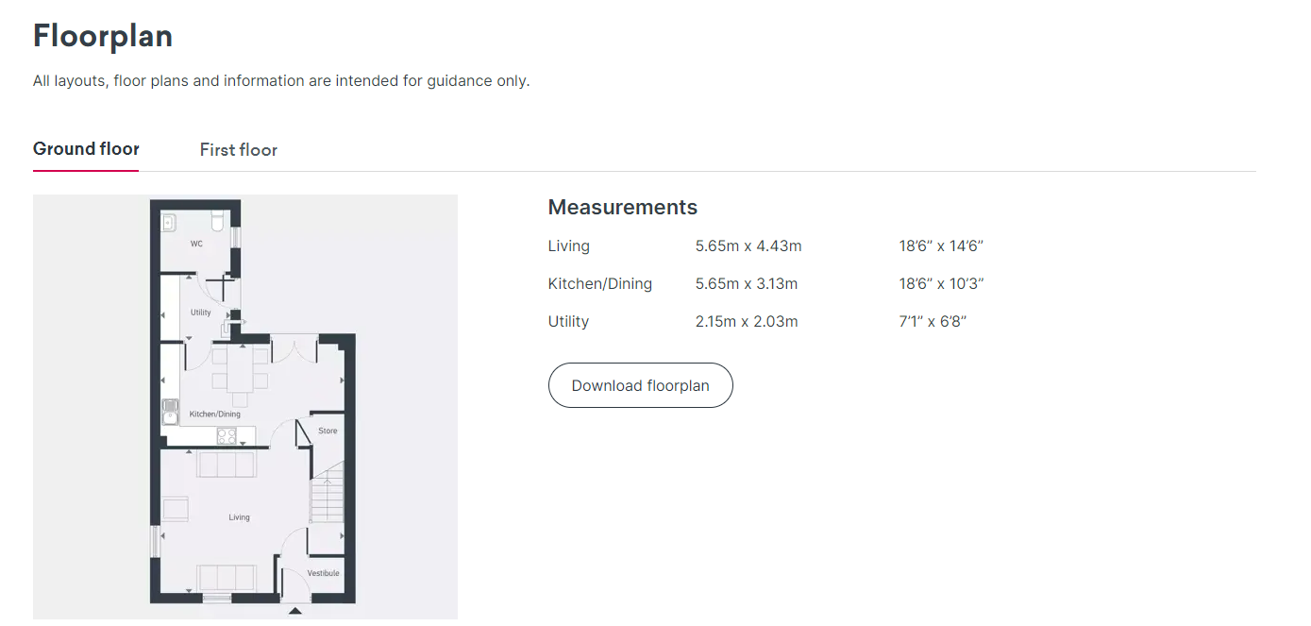**Disclaimer:** All layouts, floor plans and information are intended for guidance only.

**Related House Types**

* Please tell us a max of 3 x related house types within this Development that you’d like us to cross sell on this page:
  1. House type: Beech
  2. House type: Poplar
  3. House type: